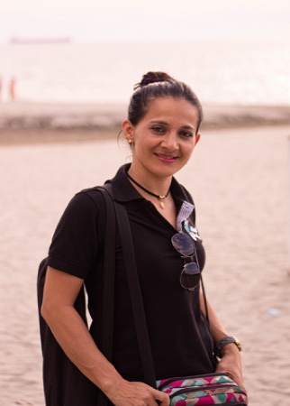

**LAUREN  
SMITH**

SEO & Digital Marketing Specialist

Experienced professional with extensive knowledge of Digital Marketing and Search Engine Optimization, holding a MSc in Business Administration and a BA In Marketing from Boston College.

**OVERVIEW**

**MSc in Business Administration** 08/2015 – 06/2019

Boston College

Dissertation:

* The Age of Influence – How influencers changed the world as we know it

**EDUCATION**

**Digital Marketing Specialist** 03/2016 – 05/2020

Creative Box

**Achievements:**

* Utilized SEO principles and vastly improved our different brands’ Google rankings
* Was primary Project Manager for the agency’s five largest accounts

**Project Manager** 02/2015 – 10/2015

The Write Agency

**Achievements:**

* Increased social media conversion by 23% in one of our major campaigns.
* Increased brand awareness by 25% in our main target audience.
* In charge of creating and curating the agency’s blog, which in turn improved our Google ranking by 220 for our most important keywords.

**WORK EXPERIENCE**

SEO | Influencer Marketing | Content Marketing

Video Production

**INTERESTS**

**Social Media Manager** 10/2013 – 07/2016

Doctors Without Borders

**Task/Achievements:**

Launched two campaigns that raised a total of $500 000.

**VOLUNTEER WORK**

**English**

**Spanish**

**German**

**LANGUAGES**

SEO & SEM | WordPress | HTML & CSS

Email Marketing | Google Analytics

Keyword Optimization | Ahrefs

Project/Campaign Management

**SKILLS**

Facebook Business Manager Certification (05/2018)

Google Ads Certification (07/2017)

**CERTIFICATES**

**CONTACT**

111-222-3333

lauren.smith@cowrite.com

linkedin.com/in/lauren.smith



Nevada, United Sates

lauren-smith.com

